|  |
| --- |
| **Domino's Pizza® Point of Sales Kiosk**  **Software Development Plan**  **Version 1.0**  **9/16/2014**  **Mismanagement, Inc.**  Tonya Brenner  Jennifer Hoffman  Michael Reinitz  Michael Schmidt |

# 

**Table of Contents**

1. Introduction

1.1 Purpose

1.2 Scope

1.4 References

1.5 Overview

2. Project Overview

2.1 Project Purpose, Scope, and Objectives

2.2 Assumptions and Constraints

2.3 Project Deliverables

2.4 Evolution of the Software Development Plan

3. Project Organization

3.1 Organizational Structure

3.2 External Interfaces

3.3 Roles and Responsibilities

4. Management Process

4.1 Project Estimates

4.2 Project Plan

4.2.1 Phase Plan

4.2.2 Iteration Objectives

4.2.3 Releases

4.2.4 Project Schedule

4.2.5 Project Resourcing

4.3 Project Monitoring and Control

4.3.1 Requirements Management

4.3.2 Quality Control

4.3.3 Reporting and Measurement

4.3.4 Risk Management

4.3.5 Configuration Management

5. Miscellaneous

|  |  |  |  |
| --- | --- | --- | --- |
| **Date** | **Version** | **Description** | **Author(s)** |
| 9/11/2014 | 1.0 | Draft | Jennifer Hoffman, Michael Reinitz, Tonya Brenner, Michael Schmitt |
|  |  |  |  |
|  |  |  |  |

Table 1.0 Revision History

# 1. Introduction

This plan describes the development of the Domino’s Pizza® Point of Sales Kiosk. The kiosk is a stand-alone software application designed to allow employees to create a pizza order, including the selection of options and the pricing of the order. The application will generate receipts.

# 

## 1.1 Purpose

This Software Development Plan (SDP) will describe the information and activities for managing the development of the Domino’s Pizza® Point of Sales Kiosk (kiosk). The SDP will describe the product, the participants, the stakeholders, the phases of development, the testing strategy, and how risks will be managed. The SDP will identify artifacts that will be generated by this project (refer to section 4.2.3).

The development team, composed of the project manager, designer, developer, and tester, will be guided by this SDP. Other roles will be delegated between these members of the team. This document will be reviewed by the customer.

## 1.2 Scope

This SDP describes the entirety of the Domino’s Pizza® Point of Sales Kiosk project. This is a stand-alone desktop application that does not interface with any other system. Included in the scope of this plan are the requirements, design, construction, implementation, and deployment of the kiosk.

**1.3 Definitions, Acronyms, and Abbreviations**

|  |  |
| --- | --- |
| Demo | Demonstration |
| Kiosk | Domino’s Pizza® Point of Sales Kiosk |
| SDD | Software Design Document |
| SDP | Software Development Plan |
| SRS | Software Requirements Specification |
| STP | Software Test Plan |

## 1.4 References

Software Development Plan, 9/16/2014, Bob Tracy.

## 1.5 Overview

This Software Development Plan contains the following information:

|  |  |
| --- | --- |
| Project Overview | Provides a description of the project's purpose, scope, and objectives. It also defines the documents and kiosk that will be delivered. |
| Project Organization | Covers the organization of the team, the external interfaces, and the team’s roles and responsibilities. |
| Management Process | Defines the major phases and milestones for the project, based on a fixed schedule. It also describes how progress will be tracked. |
| Applicable Plans and Guidelines | Provides an overview of the software development process, including methods, tools and techniques to be followed. |

Table 2.0 Software Development Plan Overview

# 2. Project Overview

## 2.1 Project Purpose, Scope, and Objectives

Refer to Section 1.1 for the purpose, Section 1.2 for the scope, and Section 1.5 for the objectives.

## 

## 2.2 Assumptions and Constraints

This is a list of assumptions that this plan is based on. For the project to run, the following must be present:

* Computer, Monitor, Keyboard, and Mouse
* Windows NT 7.0 Operating System (deployment environment)
* Mac OSX 10.7.5 or later (development environment)
* Java Version 7 or later
* Disk space in which to store the configurable data
* Users are knowledgeable of computer systems and able to use a keyboard and mouse

## 2.3 Project Deliverables

For each iteration the team will deliver a document, prototype, or application. Refer to 4.2.4 Project Schedule for delivery dates and specific deliverables.

## 2.4 Evolution of the Software Development Plan

|  |  |  |
| --- | --- | --- |
| **Expected Release Date** | **Version Number** | **Remarks** |
| September 16, 2014 | Version 1.0 |  |
| October 7, 2014 | Version 2.0 | Updated Version |
|  |  |  |

Table 3.0 Evolution of the Software Development Plan

The Software Development Plan will be subject to unscheduled revision and reissue if any of the following but not limited to criteria occur:

* Project requirement change
* Available resources change

# 3. Project Organization

## 3.1 Organizational Structure

This project has a team of four with the following primary roles: project lead, designer, developer, and tester. The project lead will oversee the team’s efforts. The designer is responsible for translating requirements into a design. The developer is responsible for constructing the design into an executable application. The tester is responsible for the verification and validation of the application.

## 3.2 External Interfaces

This project has a single external interface which is the customer, Bob Tracy. The customer is responsible for providing input resulting in requirements and accepting the final product. The customer may be consulted on issues of risk.

## 3.3 Roles and Responsibilities

|  |  |
| --- | --- |
| Person | Project Role(s) |
| Tonya Brenner | Tester, Human Factors |
| Jennifer Hoffman | Project Lead, Systems Engineer, Quality Assurance, Logistics |
| Michael Reinitz | Developer, Configuration Manager, Technical Writer |
| Michael Schmit | Designer, Design, Risk Management |

Table 4.0 Roles and Responsibilities

There will be crossover in the roles due to schedule and resources constraints. For example, the project lead will contribute towards construction.

# 4. Management Process

## 4.1 Project Estimates

The estimated project cost is $0.00. There will be a labor cost estimated at six hours per team member per week. The software development environment, Eclipse, is free of charge. A subscription for Visual Studio is provided by St. Mary’s College of Maryland. The hardware is provided by St. Mary’s College of Maryland. The costs will be re-estimated in the event that more resources or labor are needed. For the project schedule, see Section 4.2.4.

## 4.2 Project Plan

The tentative schedule is as follows:

* SDP document first draft by 9/16/2014
* SRS Document by 9/23/2014
* Traceability Matrix by 9/30/20144
* Software Design Document by 10/7/2014
* SDP Version 2 Document by 10/21/2014
* SRS Version 2 Document by 10/23/2014
* Traceability Version 2 Matrix by 10/28/2014
* SDD Version 2 by 11/6/2014
* Software Test Plan by 11/11/2014
* STP Version 2 Document by 11/20/2014
* Delivery list of documentation, media, etc by 12/2/2014
* Delivery of product 12/9/2014 with formal presentation and source code.

Resources may include the following:

* Computers
* Laptops
* Eclipse IDE
* Projector for demonstrations
* Customer

## 4.2.1 Phase Plan

Refer to Section 4.2.1.1 for Gantt Chart showing the allocation of time to the project phases. The time of the project has been broken down evenly into five sections. Each section of the Gantt Chart found in Section 4.2.1.1 represents one week(s) of elapsed time, with section one refering to weeks one through three, section two refering to weeks four through six and so on.

Refer to Section 4.2.4 for the major project milestones. Achievement criteria will be determined with the SRS and Traceability Matrix.

### 4.2.1.1 Gantt Chart

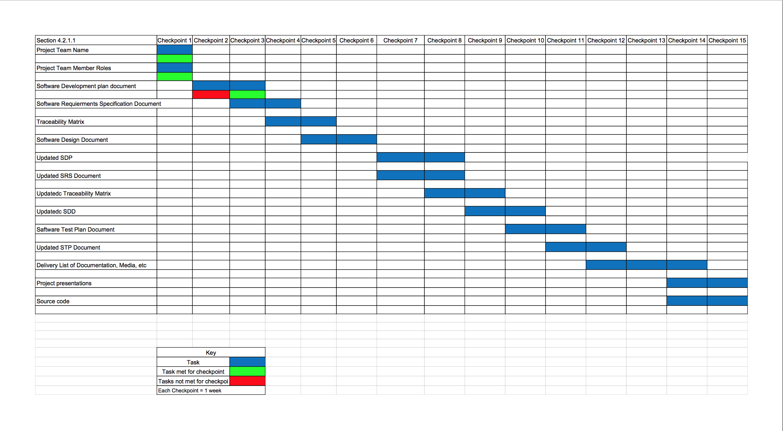

Gantt Chart Version 1.0

## 4.2.2 Iteration Objectives

Through each iteration of our spiral development we seek to produce documentation and develop a functioning and quality product for our customer.

## 4.2.3 Releases

There will be three software releases. The first will be a demo completely non-functional just a mockup of the software included in the first SDD. The second will be a semi-functional GUI layout included in the updated SDD. The final release will be a full release of the functioning software.

## 4.2.4 Project Schedule

|  |  |  |
| --- | --- | --- |
| Task | Target Date | Description |
| SDP Document | 9/16/2014 | Software Development plan |
| SRS Document | 9/23/2014 | Describe required system software |
| Traceability Matrix | 9/23/2014 | Document to assure each requirement is met by the design plan |
| SDD Document | 9/30/20144 | Document disclosing the design of the software |
| Updated SDP Document | 10/7/2014 | Updated plan |
| Updated SRS Document | 10/21/2014 | Updated required system software |
| Software Demo 1 | 10/23/2014 | Nonfunctional Interface Demo |
| Updated Traceability Matrix | 10/28/2014 | Updated Document to assure each requirement is met by the design plan |
| Updated SDD Document | 11/6/2014 | Updated Software Design Document |
| STP Document | 11/11/2014 | Plan for testing the software |
| Software Demo 2 | 11/18/2014 | Semi-functional Interface Demo |
| Updated STP Document | 11/20/2014 | Plan for testing the software |
| Delivery list of documentation, media, etc | 12/2/2014 | List of all documents and media to be delivered |
| Delivery of Product with Presentation | 12/9/2014 | Final release of software |

Table 5.0 Project Schedule

## 4.2.5 Project Resourcing

This project will require four team members. Refer to Section 3.3 for project team member roles. All four members have experience in Java. However, team members may require training in another language. This training would have to be completed prior to 10/23/2014.

## 4.3 Project Monitoring and Control

Requirements Management: The requirements will be collected from the customer and recorded in a requirements document. This document is subject to change.

Quality Control: We will use the STP and the Traceability Matrix to verify the quality of the product.

Reporting and Measurement: Refer to Section 4.2.4 for a list of documentation that will be produced for the project.

Risk Management: Refer to Section 4.3.4. In the beginning of each iteration, risks will be evaluated by the team. Risks will be analyzed and prioritized based upon their traceability to essential or desirable requirements.

Configuration Management: Problems and changes should be submitted to the Quality Assurance Department via email or phone call. Projects should be saved on multiple computers. Projects may be saved as PDF or Microsoft Word (2007 or newer) document type. Projects should be named “Mismanagement_[document title abbreviation][version number #.#]”. Versions should be numbered accordingly with a major change being an integer numeration and a smaller change being a decimal numeration.

## 

## 4.3.1 Requirements Management

The requirements for this application are captured in the SRS. Requested changes to requirements are captured in an updated SRS (SRS Version 1.2 or later), and are approved as part of the Configuration Management process.

## 4.3.2 Quality Control

Defects will be recorded and tracked as previous documents saved on file for reference. See Section 4.3.3 for further information on reporting and changes.  
  
All deliverables will be reviewed throughout each iteration. Each review will ensure that each deliverable is of acceptable quality.  
  
Any defects found during review which are not corrected prior to releasing for integration must be captured and submitted to Quality Assurance so they are not forgotten.

## 4.3.3 Reporting and Measurement

Updated schedule estimates, and documentation, will be generated at the end of each iteration.

## 4.3.4 Risk Management

Each iteration, project risk is evaluated by the team. The Risk Manager will determine each risk, risk likelihood, and risk consequence. The team will identify ways to mitigate each risk.

## 4.3.5 Configuration Management

The Configuration Manager will control a repository of project artifacts and each version of the artifacts to provide a history of change.

All source code, test scripts, and data files are included in baselines. Documentation related to the source code is also included in the baseline, such as design documentation. All customer deliverable artifacts are included in the final baseline of the iteration, including executables.  
  
The changes are reviewed and approved by the appropriate team member.